**COMPUTER NETWORKS - CSA07**

**Parthibhan .R**

**192224275**

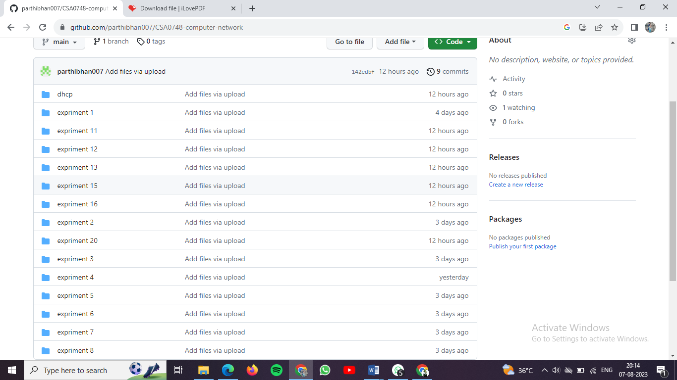

GITHUB LINK:-

<https://github.com/parthibhan007/CSA0748-computer-network>